SET 7 – CUSTOMER DEMOGRAPHICS ANALYSIS
Ayesha Siddiqa S -04
192324305
Dataset: Customer Demographics
Customer ID | Age | Gender | Income ($)
1 | 28 | Female | 50,000
2 | 35 | Male | 60,000
3 | 42 | Female | 75,000

Question 1: Create a Bar Chart to Visualize the Distribution of Customer Ages
Aim
To visualize the age of each customer using a bar chart.
Algorithm
- Import or enter the customer demographic data into Tableau.
- Drag Customer ID to Columns.
- Drag Age to Rows.
- Select the Bar Chart option.
- Add suitable axis labels and chart title.
Tableau Steps
- Columns: Customer ID
- Rows: Age
- Marks: Bar
- Title: Customer Age Distribution

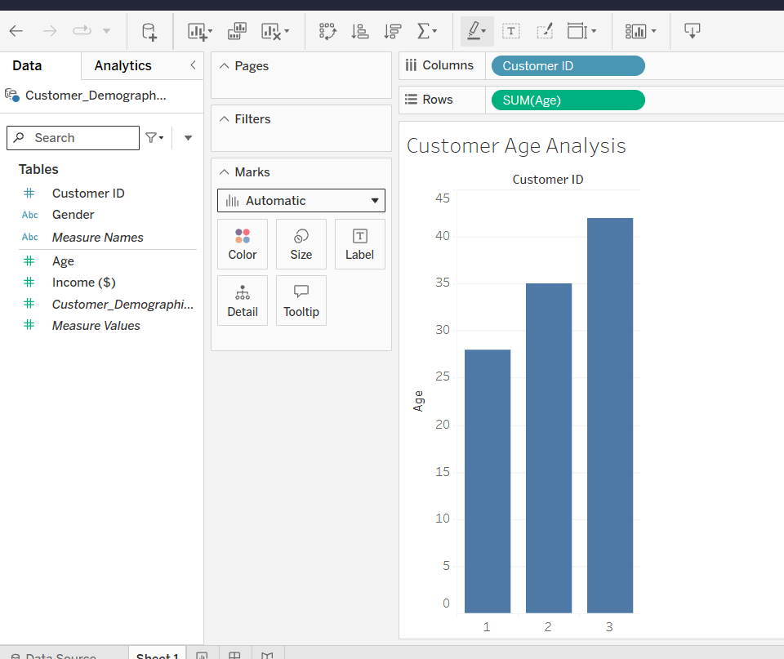
Observation
The customers have ages 28, 35 and 42. Customer 3 is the oldest, while Customer 1 is the youngest.

Question 2: Generate a Pie Chart to Represent the Distribution of Customers by Gender
Aim
To represent the proportion of customers based on gender using a pie chart.
Algorithm
- Select the Gender field.
- Change the Marks type to Pie.
- Drag Gender to Color.
- Drag Customer ID to Angle and Label.
- Display the percentage of each gender.
Tableau Steps
- Marks: Pie
- Color: Gender
- Angle: Customer ID
- Label: Customer ID / Percentage

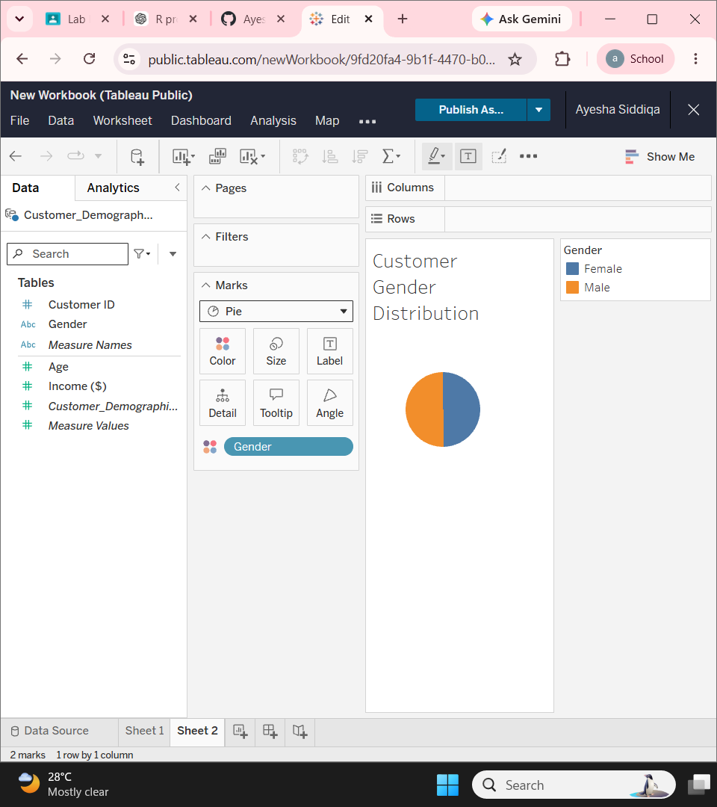
Observation
There are 2 female customers and 1 male customer.
- Female = 66.7%
- Male = 33.3%

Question 3: Build a Table to Show Demographic Information
Aim
To display the complete demographic information of each customer in a table.
Algorithm
- Select Customer ID.
- Add Age, Gender and Income.
- Arrange the fields as columns.
- Display the data as a text table.
- Add appropriate column headings.

Table
Customer ID | Age | Gender | Income ($)
1 | 28 | Female | 50,000
2 | 35 | Male | 60,000
3 | 42 | Female | 75,000
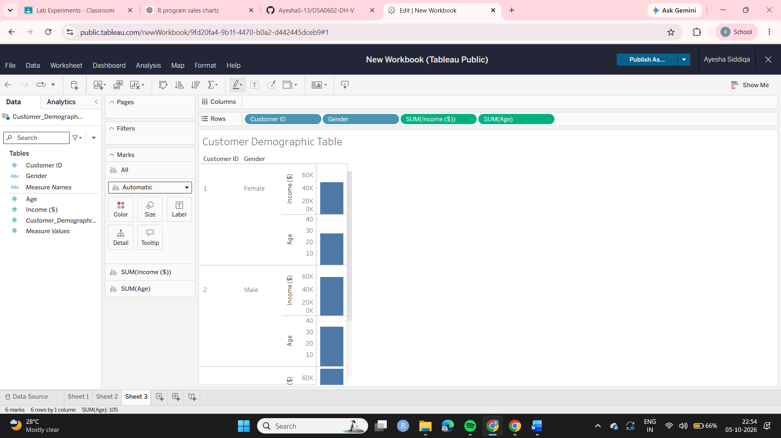
Observation
The table provides a clear view of each customer's age, gender and income. Customer 3 has the highest income of $75,000.

Question 4: Develop a Tableau Dashboard
Aim
To combine the bar chart, pie chart and demographic table into an interactive Tableau dashboard.
Algorithm
- Create the age bar chart.
- Create the gender pie chart.
- Create the demographic table.
- Select New Dashboard.
- Drag all three worksheets into the dashboard.
- Add filters or dashboard actions if required.
- Format the dashboard with suitable titles.
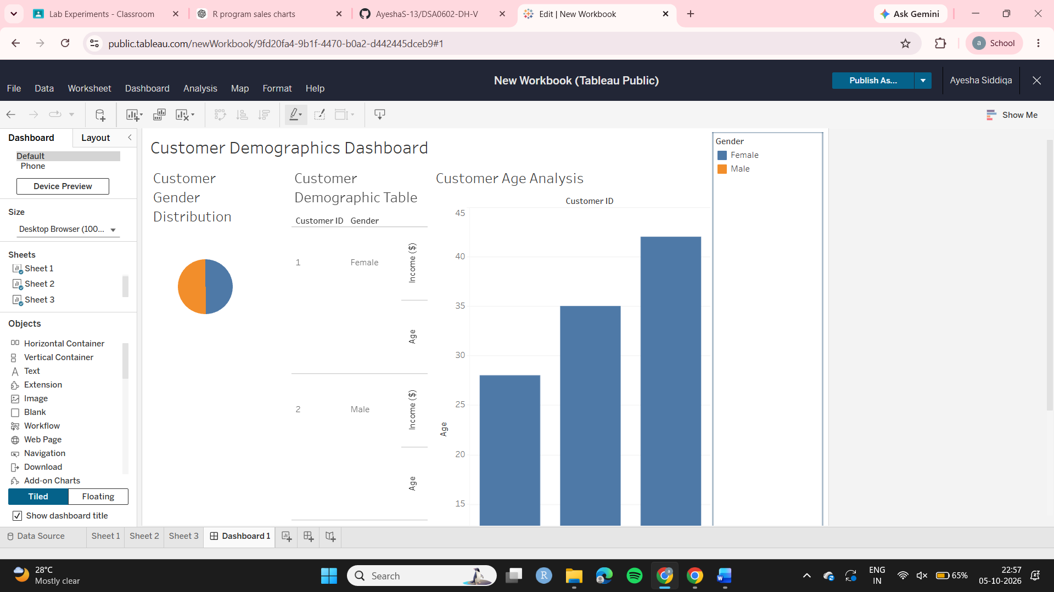
Observation
The dashboard combines customer age, gender and income information in one view. It allows users to understand the demographic distribution easily.

